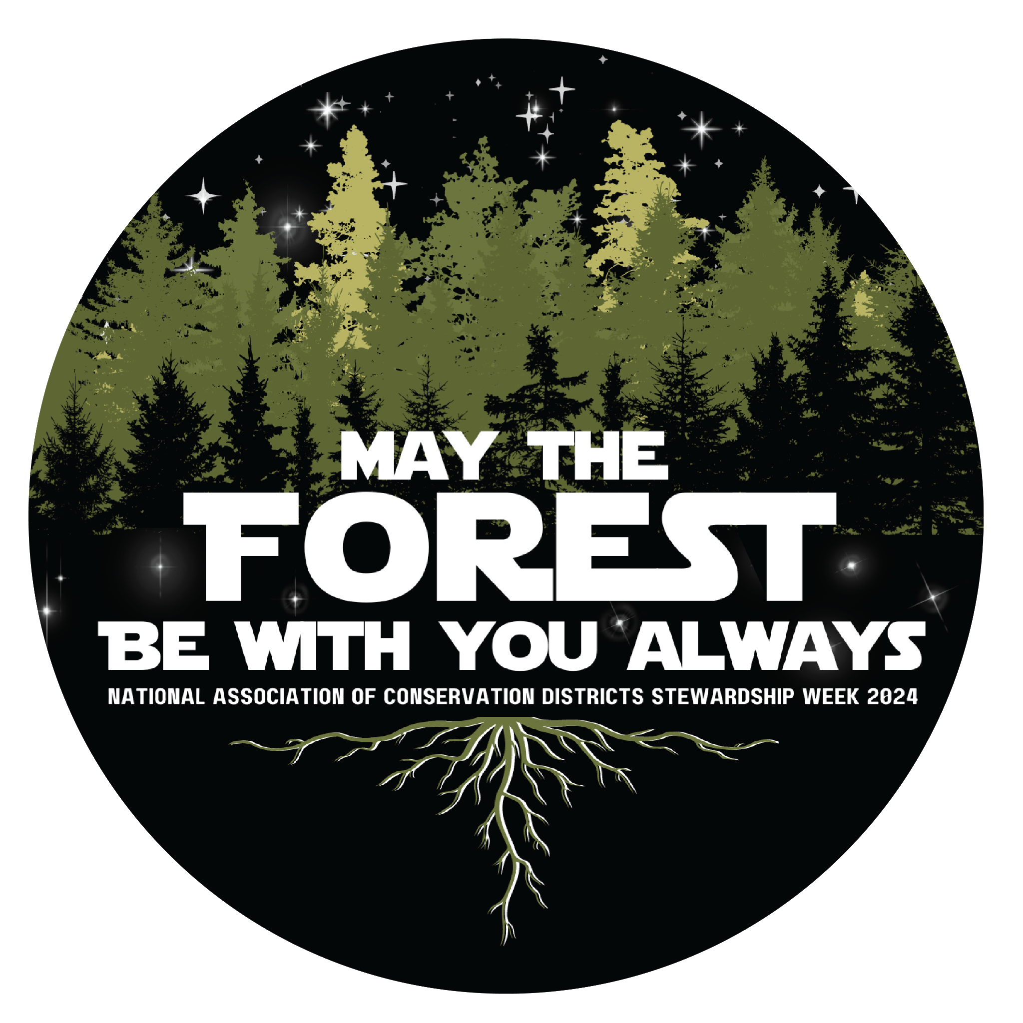

**SLV Conservation Poster Contest**

**Quick Guide**

Part of the National Association of Conservation Districts Poster Contest

**Due October _28__**

**Poster Instructions**:

* The theme title; **“MAY THE FOREST BE WITH YOU ALWAYS**” must be on the poster
* Double-check spelling before using markers/colored pencils
* Must be the students’ original artwork. (individual submissions, not as a team)
* Don’t put students’ name or school on the front of the poster
* Use white 14X22’’ poster board. (regular poster board cut in half)
* Tape the entry form to the back after a parent and guardian has signed

***WHAT MAKES A GOOD POSTER? - Include these poster assets:***

*Attracts Attention – Is simple and concise – Uses colors and white space effectively – Text is large enough to be easily read…*

*• A brief, catchy message; one that can be read in 10 seconds. (Theme Title Must Be Included)*

*•Convey a message about conservation, making the viewer care about the issue.*

*• Letters large enough to be easily read*

*• Principles of good design, good use of the entire poster area.* 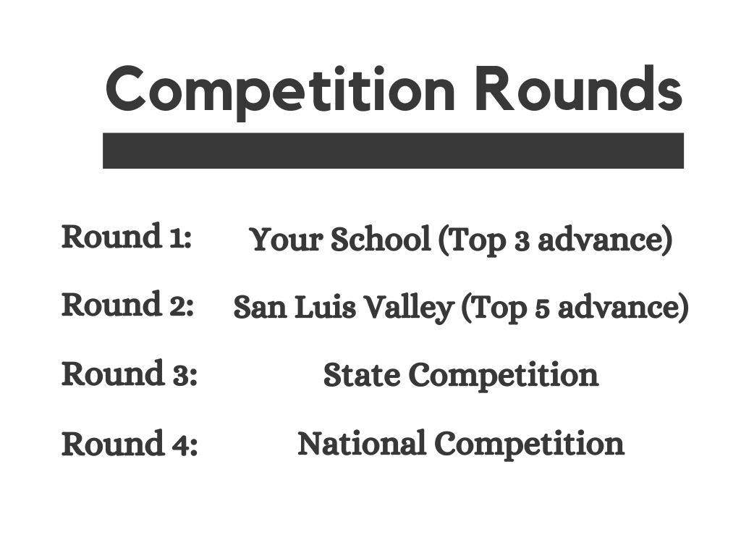

**Helpful Links and topic research:**

[Slide Show Presentation Copy](https://docs.google.com/presentation/d/18mqrSscYsSIyFZ7FqN3lVx6Uo7-Rhts8FhiC8-d3hhw/edit?usp=sharing)

[Video- Forests, Colorado Open lands](https://youtu.be/QamoudTkErE?si=nGRxtoAm4-ClHJpS)

[Video- Forest Restoration](https://youtu.be/oPIsTUC_35o)

[Video- Colorado’s Forests: past, present, future](https://youtu.be/t5MVM6R9nCU)

[Things you can do](https://www.nationalforests.org/blog/ten-things-you-can-do-to-help-our-national-forests)

[Colorado Forest Facts](https://csfs.colostate.edu/media/sites/22/2018/08/305770_Colorado_Forest_Facts-www.pdf)

[Arbor Day- tree benefits](https://www.arborday.org/trees/index-benefits.cfm?utm_source=Arborday.org&utm_medium=Top_Menu&utm_campaign=Dropdown_Menu&utm_term=Trees&utm_content=Tree_Benefits)

Posters will be taken to your Conservation District to be judged, and two posters per district will be taken to the 2024 CACD (Colorado Association of Conservation Districts) Annual Meeting in November where state winners are selected. You should hear back about winners by the end of November, and prizes will be awarded soon after. Visit [rgwcei.org/postercontest](http://rgwcei.org/postercontest) for more information.